To: |  |  |  | Shareholder and Joint Venture Group
Date: |  |  |  | Wednesday 22 June 2022
Report of: |  |  |  | Sarah Knight, Head of Development
Title of Report: |  |  |  | Quarterly Progress Report relating to Barton Oxford LLP
 | Summary and recommendations
 | Purpose of report: |  | This report provides an update into the activities of Barton Oxford LLP (BOLLP) over the past quarter.
 | Recommendation(s):There is a resolution to:
 |  | Note the contents of the report.

Appendices
None

Introduction and background
- This is the twelfth report to the Shareholder and Joint Venture Group covering the period since the previous update in March 2022.

Progress Update

First Phase
- Hill have now got 236 homes occupied with only the sales office left to complete on this site. 95 of these homes are affordable. The sales office conversion is nearly complete and this will conclude all Hill’s sales on the scheme.
- At the last meeting, it was reported there was a delay in the completion of the s38 (highways adoption) with the County Council. This has progressed with the works to the road receiving the necessary practical completion certificate and put into the 12-month maintenance period. At the end of this, the Final Certificate of Adoption will be obtained.

Second Phase
- This phase is to deliver 207 homes in total of which 83 are affordable. As at the end of May, Redrow had completed 41 private homes and 14 affordable homes. The next batch of 12 affordable homes are on target to be handed over in June 2022.

Third Phase
- Countryside’s application for phases 2 and 4 was validated in November 2021 and received resolution to grant planning permission at Planning Committee on 24th May 2022. It comprises a mix of 434 houses and apartments with 174 affordable homes. Countryside have taken over the management contract for the site and are gearing up to start as soon as the permission is granted.

- It is understood that 95 homes from Countryside’s 434 homes will be sold to Places for People as shared ownership homes. Further details on this transaction are awaited.

Final Phase
- Legal work is underway to progress the sale with the successful bidder for phase 3b. Their pre application planning work is underway and this phase is anticipated to be for 22 homes. This will need to be a new full application because the 885 homes from the original outline permission have almost entirely been delivered by the previous phases. Therefore the majority of the homes in phase 3b will be additional. It is anticipated that this phase will be 100% affordable and at high levels of sustainability.

Public Art
- The Public Art obtained its required planning approval in April culminating in a public art launch on the 15th April. Over 480 people attended this “Wanderlust” event which included live music, food and activities. There was significant media interest both through social channels and more traditional routes such as BBC Radio Oxford.

- The majority of the art has now been installed and includes rockeries, tiered gardens, parklets and living animal sculptures. This has been developed with community involvement. The well-being garden is in use for social prescribing courses.

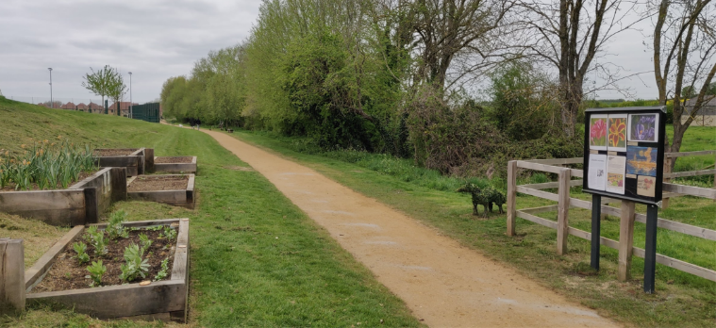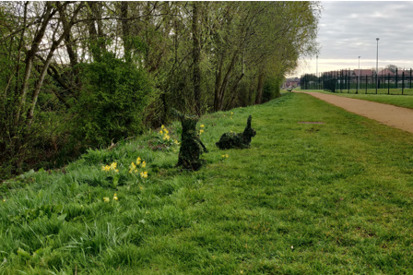

Community Employment Plan
- The Community Employment Plan (CEP) purpose is to provide employment support and employment opportunities for local businesses (in particular SMEs) and residents (in particular young people, those who are disadvantaged, and those who are in long term unemployment). An updated CEP is being developed with the CEP steering group which includes representatives from BOLLP, OCC, Oxfordshire LEP, Oxfordshire Job Centre Plus, Aspire Oxford and the house builders, who help to ensure that the updated targets in the CEP now meets local needs, and is appropriately benchmarked against other projects. This has been refreshed recently and Countryside and Redrow will be expected to deliver against revised targets. There will be discussions on phase 3B as well to pass these responsibilities on to the contractor at that site.

Events
- In addition to the Public Art launch on 15th April, a residents meeting was held at Redrow Sales Office at the end of March by First Port (the managing agent). Feedback at this meeting was very positive.
- A BICEP meeting was held virtually on 23rd March, which went well with no major issues raised. The next BICEP meeting is scheduled for July and will be held at Barton Park with the opportunity to view the new public art.

Land North of Baywater Brook
- During March, further community consultation was undertaken on proposals for housing development at the land North of Bayswater Brook which is in South Oxfordshire District Council but adjacent to the Barton Park development. The proposal by Christchurch and Dorchester is currently for 1450 homes and 120 assisted living homes. The masterplan at this stage has several pedestrian and cycle links between the proposed site and Barton Park. Discussions are being held with Christchurch and Dorchester about the connections between the two sites on the basis that this site benefits from a link through Barton Park. A fuller update will be brought to the next Shareholder meeting as this progresses.

Financial Implications
- There are no financial implications arising directly from this report.

Legal Implications
- There are no legal implications arising directly from this report.

Report author | Sarah Knight
Job title | Head of Development
Service area or department | Housing Services
Telephone | 07483 010867
e-mail | sknight@oxford.gov.uk

